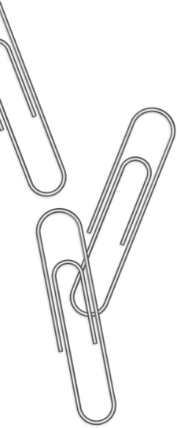

|  |  |
| --- | --- |
| 1. | 08.30 – 09.10 |
| 2. | 09.20 – 10.00 |
| 3. | 10.20 – 11.00 |
| 4. | 11.20 – 12.00 |
| 5. | 12.10 – 12.50 |
| 6. | 13.00 – 13.40 |
| 7. | 13.50 – 14.30 |
| 8. | 14.40 – 15.20 |

Звонки

|  |  |
| --- | --- |
| 1. | 08.30 – 09.10 |
| 2. | 09.20 – 10.00 |
| 3. | 10.20 – 11.00 |
| 4. | 11.20 – 12.00 |
| 5. | 12.10 – 12.50 |
| 6. | 13.00 – 13.40 |
| 7. | 13.50 – 14.30 |
| 8. | 14.40 – 15.20 |

Суббота

|  |  |
| --- | --- |
| 1. |  |
| 2. |  |
| 3. |  |
| 4. |  |
| 5. |  |
| 6. |  |
| 7. |  |
| 8. |  |

Пятница

|  |  |
| --- | --- |
| 1. |  |
| 2. |  |
| 3. |  |
| 4. |  |
| 5. |  |
| 6. |  |
| 7. |  |
| 8. |  |

Четверг

|  |  |
| --- | --- |
| 1. |  |
| 2. |  |
| 3. |  |
| 4. |  |
| 5. |  |
| 6. |  |
| 7. |  |
| 8. |  |

Вторник

|  |  |
| --- | --- |
| 1. |  |
| 2. |  |
| 3. |  |
| 4. |  |
| 5. |  |
| 6. |  |
| 7. |  |
| 8. |  |

Среда

|  |  |
| --- | --- |
| 1. |  |
| 2. |  |
| 3. |  |
| 4. |  |
| 5. |  |
| 6. |  |
| 7. |  |
| 8. |  |

Понедельник

|  |  |
| --- | --- |
| 1. |  |
| 2. |  |
| 3. |  |
| 4. |  |
| 5. |  |
| 6. |  |
| 7. |  |
| 8. |  |